**Pengolahan Citra Digital**

Nama : Faisal Islami

NIM : 1207070040

Kelas : TKK

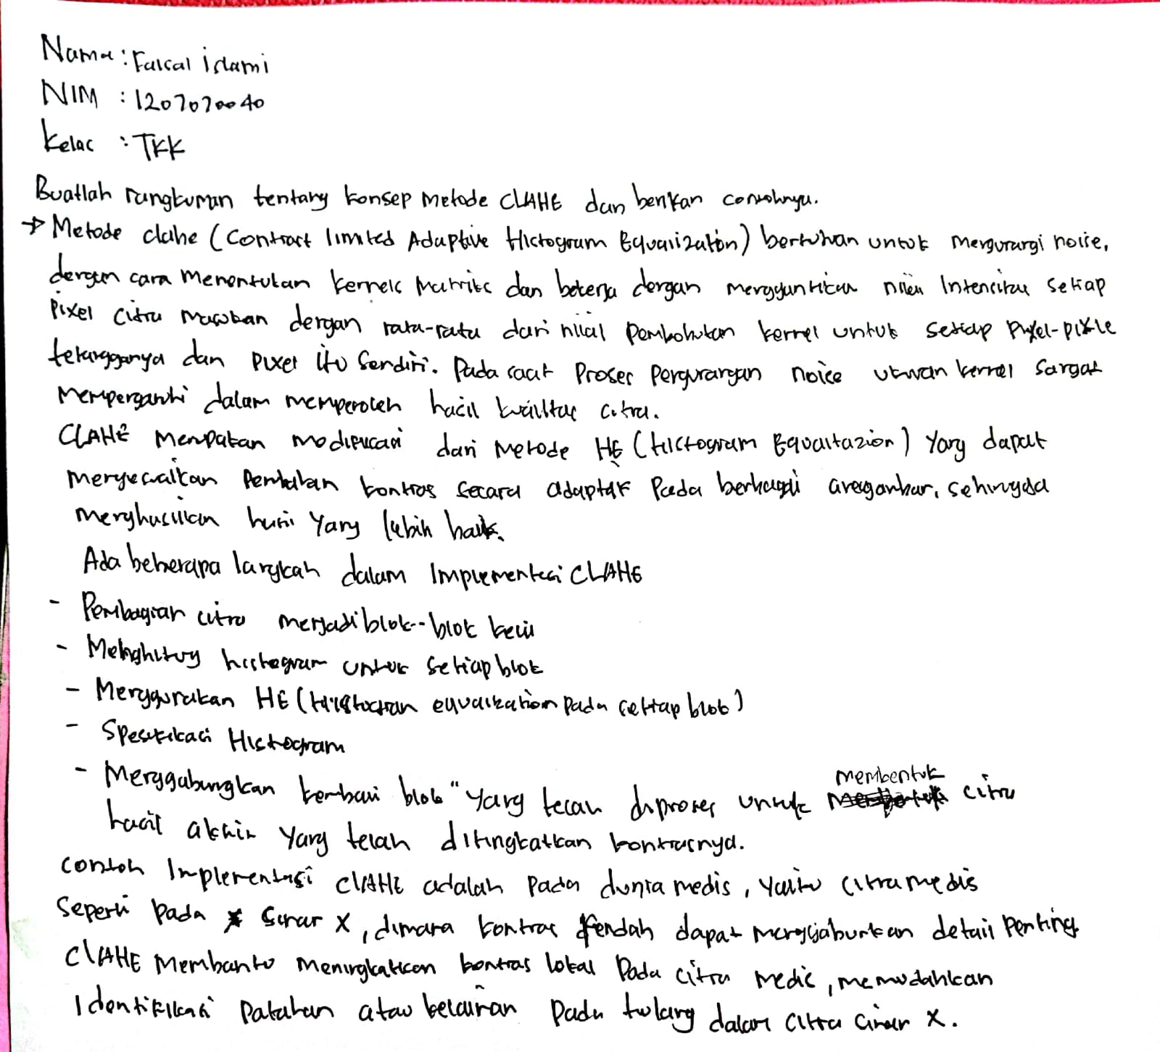

**Contrast Enhancment**

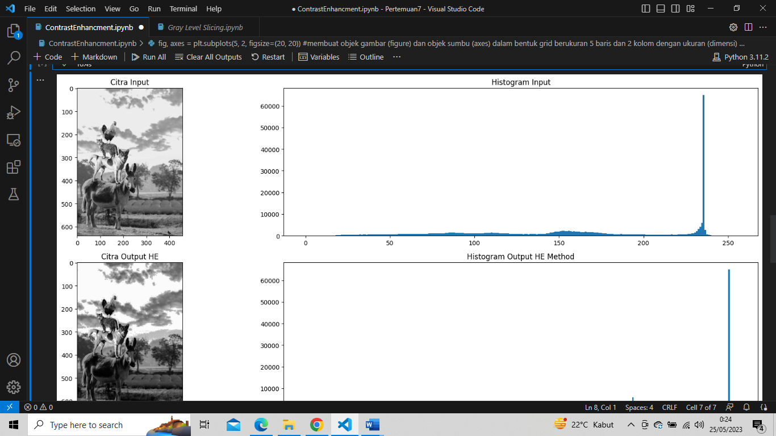

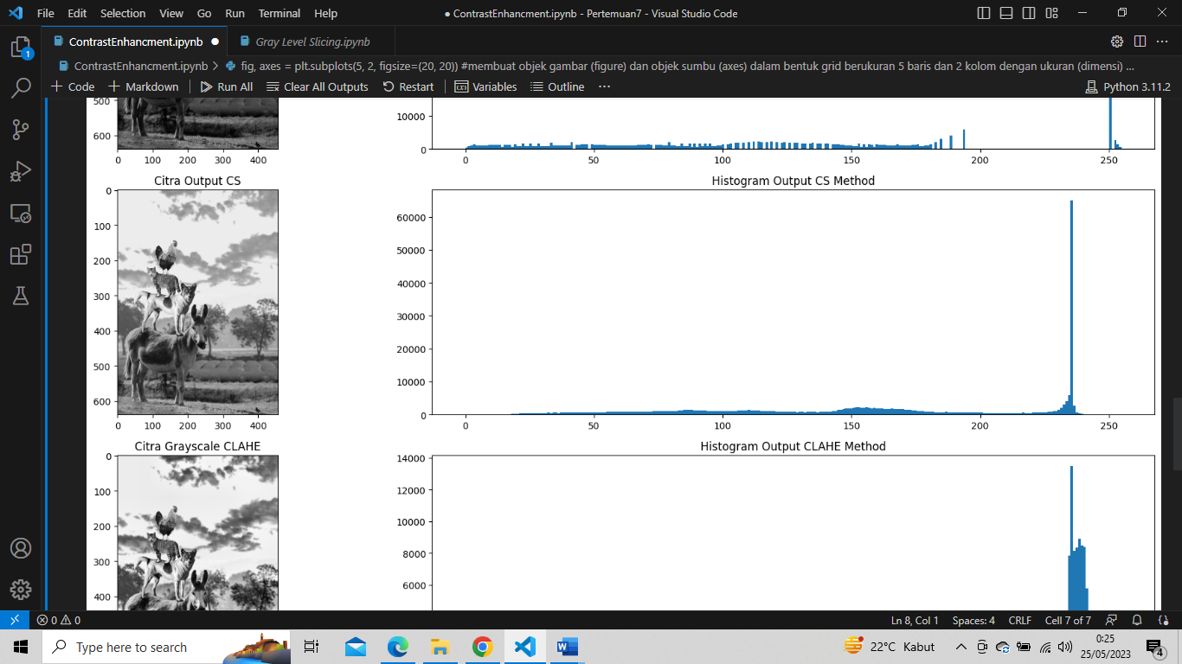

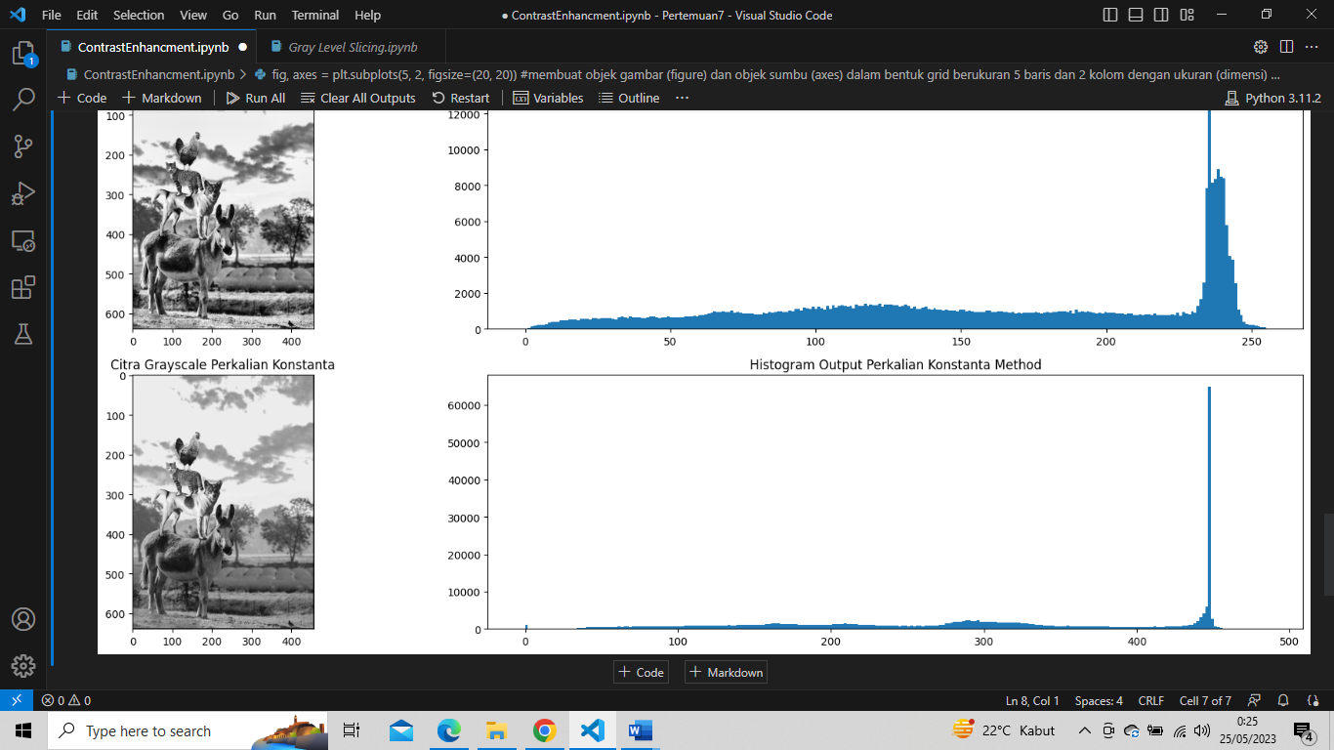

# Gray Level Slicing

# 

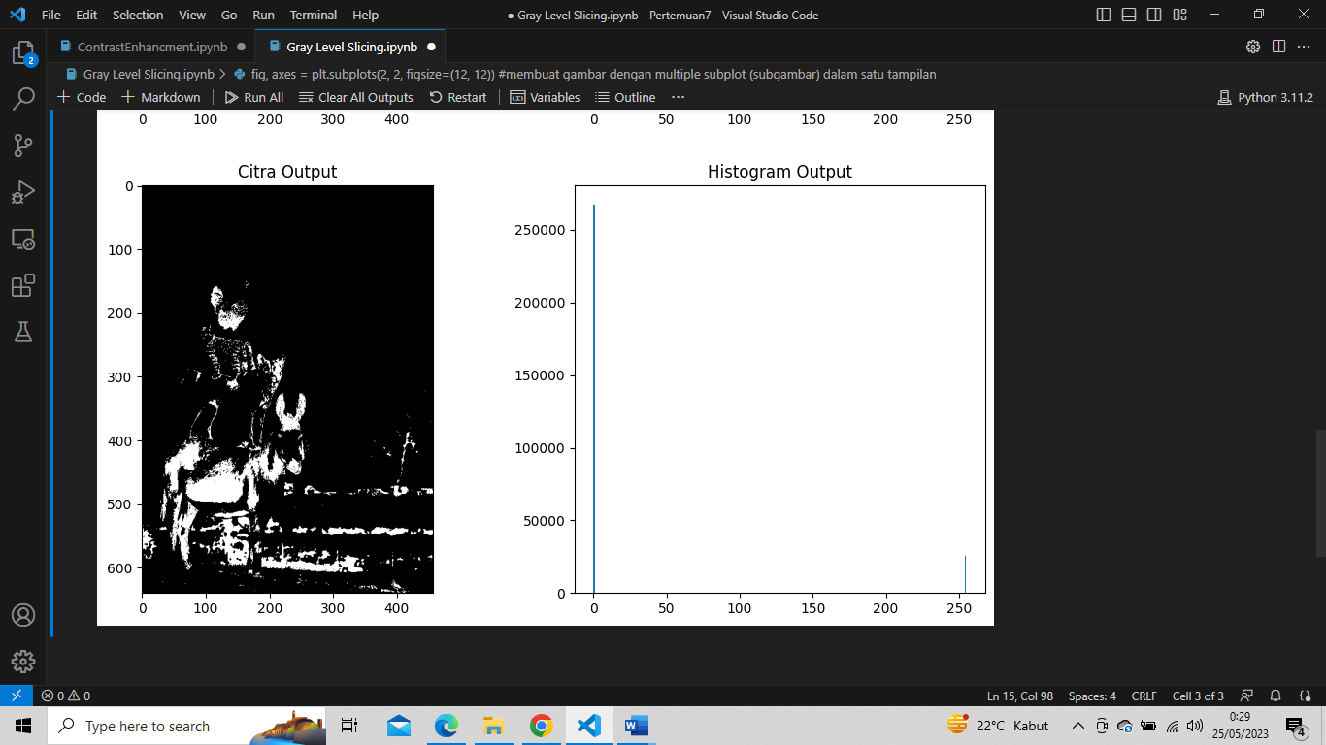

# Filter Rerata

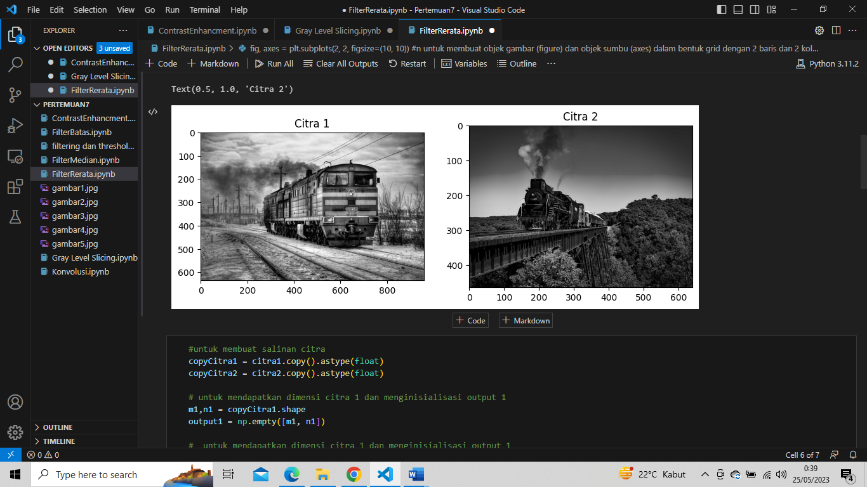

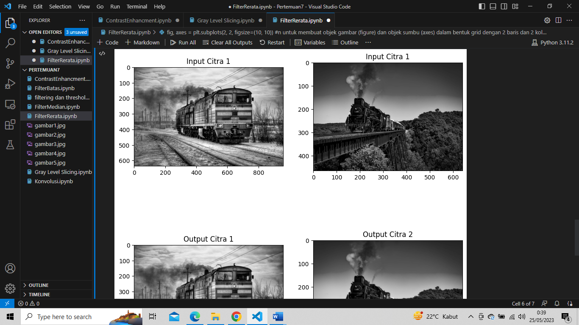

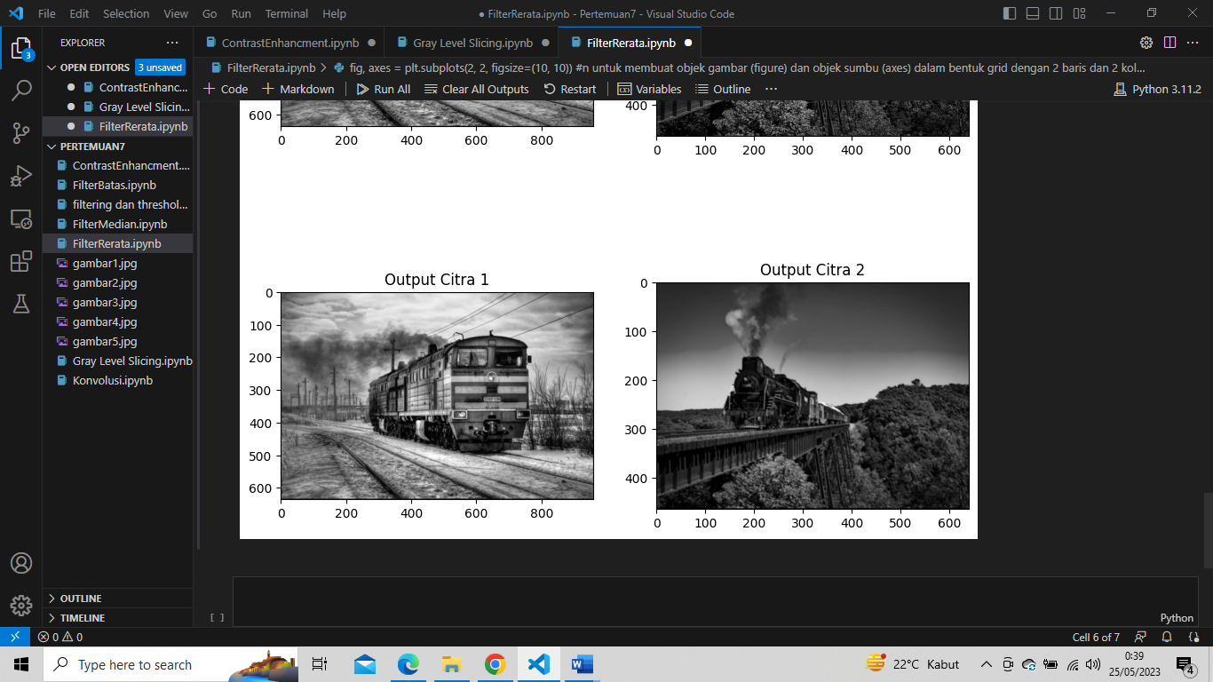

# Filter Median

# 

# 

# 

# Filter Batas

# 

# 

# 

# Konvolusi

# 

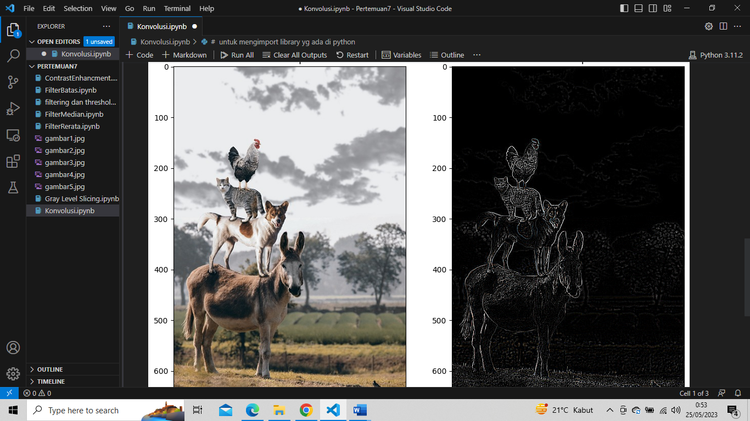

# ****Filtering dan Thresholding****

# 

# 

